C Programming----Downing Man

1Abstract
This project written by me achieves the control of the man and make the boards of the game can move down to make the game can be played,and I also made the boards have more function, so that it can be more challenging.Once you control the start touch the upper baffle ,drop down or run out of your life by mistake,the game would end. You can try to get higher scores to prove yourself in the game.

- Introduction/Problem Statement
The game I designed is mainly to control the movement of characters from left to right through the keyboard, and to make myself live longer so that I can get higher scores.
When I decided to do this project, the first question was how to generate random bricks to make the game exciting and uncertain, so as to attract more users.The second problem is how to control the movement of the little man and the brick, which includes the movement of the little man down and left and right, and the relative upward movement of the brick.The third problem is that the character is stationary when he touches the brick, so that the character can stop instead of falling all the way down to death.
Group work
- Tao Pengcheng
Finish the codes and do the ppt work and finish the report.
- Zhu Junze
The final presentation(only in this time he did his job)
- Zhao Meiyi
Out of school

Analysis
- Randomly generated board
Thoughts:
3.1.1.We have learned randomly generated the figures,will it be a helpful tool as we can replace the different boards as different figures
3.1.2.We want the board appeared with the interface moving down,and interval orderly,which means we may limit the number of boards in a certain range. It may be a great help.
3.1.3We would use the console as our function,any help?

- Control the interface/man moving
3.2.1.The relative motion(the boards or the whole background ),this problem should be considered as if we should design the code to make the boards move or the background moves, different choice means different designs, to make the problem easier I choose the former solution.
3.2.2.the man's relative motion and the control of it to have a better control of the man,so that each of us could control of it fluently like the game, one more thing is that the man should drop faster than the boards.
3.2.3Also the problem,we would use the console as our function(as the function is the core of the code),any help?

- Make guy stop when touching the boards
1.The C programming could only know figures and comments,which means we can’t let it know if the man and the boards have contact.So we should replace the comment as the figures or the “c language”so that the function can be played.
2.To judge the touching,we need the bottom of the man touch the board,also the console used may be a great help. And it also means we need get the coordinates of the man every time when played, and also we may know the coordinates of each boards to avoid the man still can drop even he touch it.
3.Relationship between the two former questions?Actually,each problem have connection,I think it also need I to use the figures to replace the boards to make it more easier.

4.Design&Implementation
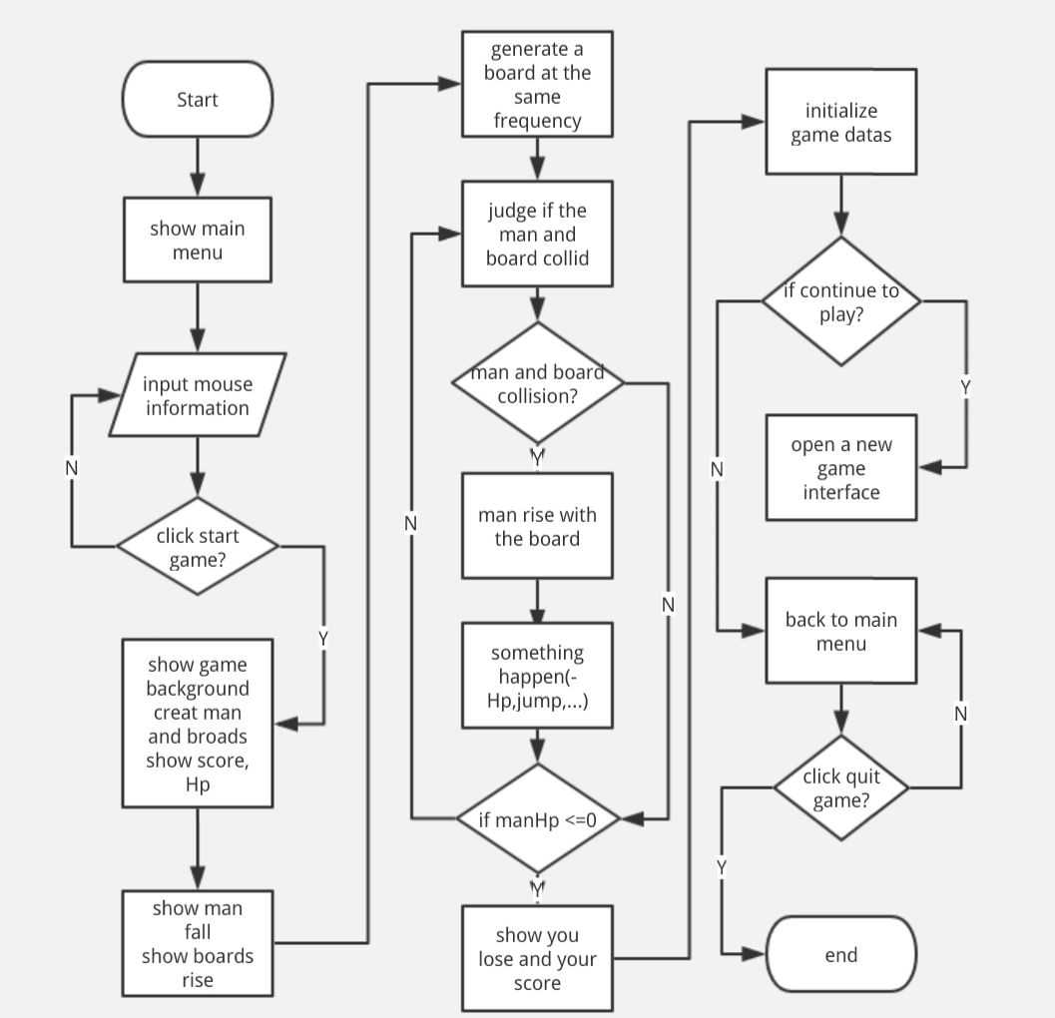
This flow chart have explained the thought of us very well and mainly answered the problems I have in the front, later I will explain the thought step by step.
4.1First, the main function
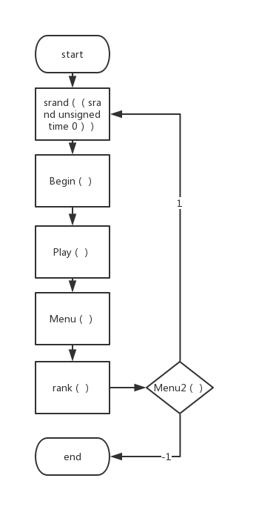
It mainly focus on the main thought of my code.We can see that it mainly tell us the thought of the main thought, which can help the code could be played.
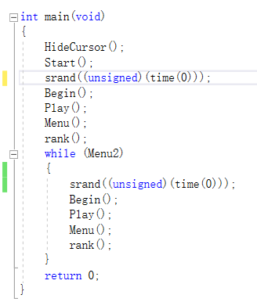
4.2The solution f the random boards
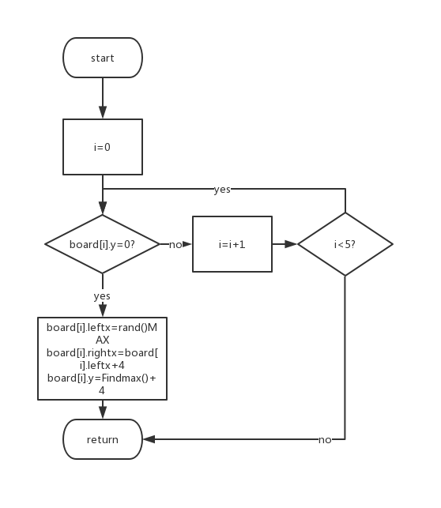
We can e that in this part we have make the different boards as different figures, it just limit the distance of the boards as 4, and the upper board disappeared while the bottom boards appear.So that the game could be more challenging.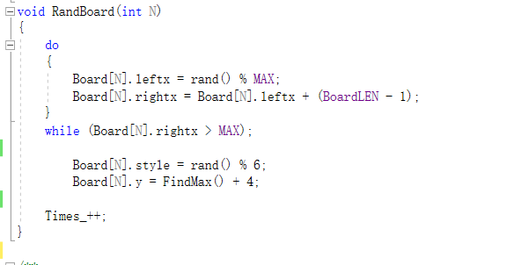As the code hows us.
4.3Soultion of the Collision Detection.
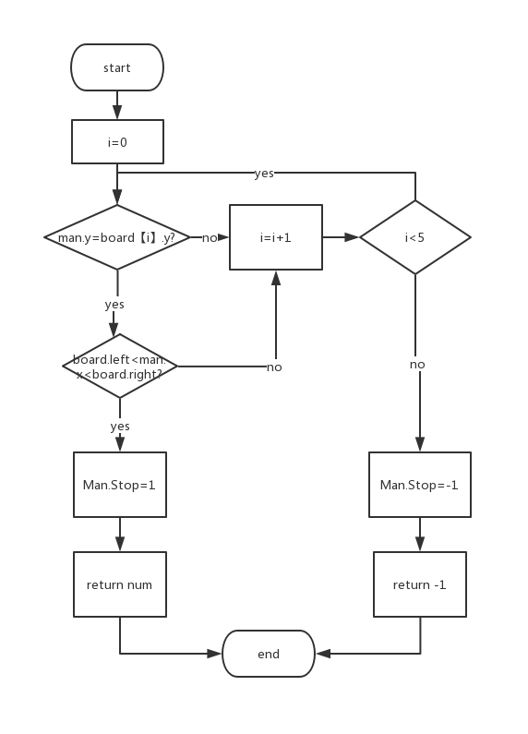
We have two roads to judge, while the man have touched the board we can see that it will returned the number of the board to make the function of different boards could be played. Also,while the man doesn’t touch the board the man would return -1 to make the guy jus drops.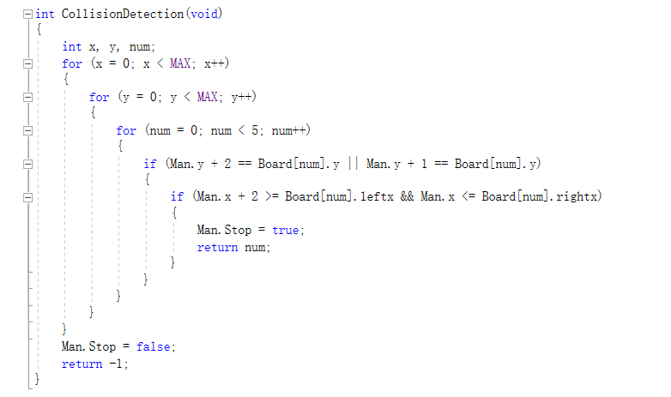
4.4Soultion of the boards moving

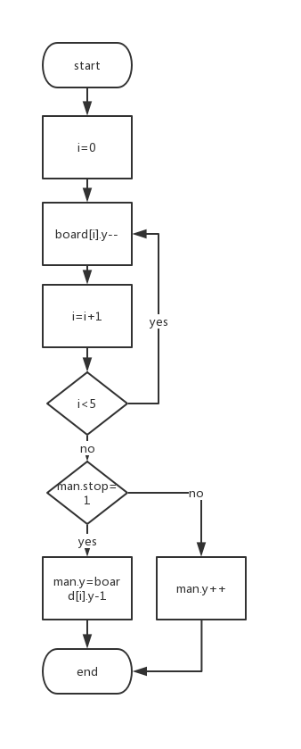
We can see this part is an easy part, but the difficult of the boars moving of the tool function used in the code. I think it mainly make us to have more ways to solve one problem.And the problem shows the y++ to make the boards go up.Also the man,it made the game could played well.

5.Result&Conclusion
In this c project, I truly gained a lot. In the programming I have finished the game could achieve some function like the player could play the game interface to get higher scores and the main interface could also meet the needs , like the scores ranking and the control also the levels of the game and so on.
But the shortages are also obvious ,like it’s not so beautiful as we just uses the console not easyx so I uses the start to replace the man ,and moreover some complex functions I haven’t reach like the get coins and the jumping board and the moving board.
I think the project is satisfying for me although it also have many shortcoming. I think the C language truly has its beauty,and I would be better next time.

